**Initial Ideas**

When starting the Undo/Redo project, there was an idea to do it with an image editor instead of the typical text editor. The idea was, due to having a static image location, it would be much easier to redo an undone item without having to consider if the position of a character was going to interfere with re-insertion if, for example, you place an additional word in front of the deleted character, moving the position into the middle of a word (and not a blank space anymore). Though this idea was later discarded as actually creating an image editor would be a challenge in itself, and open-source options were outside of our abilities. Open source options that we considered were Paint.NET (which has a version open source, but is no longer open source), and OpenOffice.

Next, the idea was to make a rick text word processor path. After a bit of tinkering, trying to learn Rich Text Format, it was decided that for the sake of the project, we would stick with a simple program, focusing strictly on the undo/redo interface (keeping in mind that said interface could be implemented in a proper word processor or even an image editor). As a result, the final project choice was a general text editor.

**Design of the Editor**

Going into the project, the first thing we decided was how we wanted to improve the undo/redo system based on our personal annoyances with modern systems. This included the inability to see the past history, not being able to undo specific parts without going through all the ones after, and of course not being able to redo stuff after modifying a document. With this in mind, we went ahead with designing the layout of the editor.

**Note**: The basic layout of the document was decided right away and wasn't changed. This included a menu at the top with your standard File and Edit items, a tool panel right underneath, a text area for the document itself, and a panel at the bottom (which in theory would include information about the state of the document). All of these are the basic elements of a common text editor, which we stuck with for the sake of learnability. Also, the standard keystrokes for undo/redo as well as other functionalities have been implemented.

The early prototype included a panel embedded to the left of the document, which could be either hidden or showing. This panel would be used to display the undo and redo history of the document in a list form. It would be resizable, and would allow the user to select specifically what they want to undo or redo. The basic undo/redo buttons would be present in the tool panel, specifically for new users who may not be familiar with the interface and for quick undos/redos. This design was ultimately discarded as it would be difficult to implement a resizing panel using Java's Swing.

Inspired from the original design, we decided to make a popup panel which would display the undo/redo history. This was used as it would allow the user to position it on the document in a way that's convenient to them. The specifics look of the list inside went through many aesthetical changes, dealing with font choices and how the history information would be presented. Initially, there was a limit set to the amount of characters shown about the user’s modifications. This was later removed as it didn't give the user access to all the information they may have needed. Instead, the panel become scrollable, allowing the user to read all the text by scrolling. It is important to note that at this point, programming the actual functionality of the undo/redo system had begun and issues were immediately apparent. Issues such as how to keep track of the position of what's being undone/redone led to the realization that certain actions would not allow any action prior to it to be undone until it itself was undone. We wanted to be able to visually display this to the user. This was done by greying out the font of elements which could not be undone, and this design was kept in the final product.

During the programming process, we were inspired with the potential of what our undo/redo could do. One of those which is lacking in many programs today is the ability to do multiple undos/redos, and with the current interface we had designed, we realized this could be implemented. Using standard control or shift clicking, the user could select multiple items at once, and if proper conditions were met, the user could undo all of them in a click of a button. This would increase the efficiency of the interface significantly, without much need to learn as this style of multiple selections is used by many basic programs (such as deleting multiple files). If the user selects an action which would cause ambiguity in the final product, an error is displayed. Though throughout the design process we wanted to avoid using popups to give information to the user, it was deemed alright for this situation as the amount of changes the user was making deserved a proper explanation as to why it didn't work.

Now with the ability to do multiple undos or redos (not both at once for technical reasons), another idea came to mind; that being allowing the user to preview the result of their undos/redos without immediately applying the changes (and thus forcing them to manually reverse it again if it is an undesired result). Beneath the history panel, a new button was added. When clicked, a new document-like text area (which doesn't allow text modification) pops up displaying exactly what the document would look like should the changes be applied. Beneath are two buttons (Apply and Discard). If the user is satisfied, they would select Apply, and if not, Discard (the close button of the window has the same effect). While in the preview state, no modification to the document can be done as that could lead to ambiguities.

At this point, we were satisfied with the interface we had created. We got together and pondered improvements. It was at then when we decided to implement a final interface which would allow the user save the history alongside the document. In other words, when exiting the program, the user could reload the history of their document and undo and redo what they did in their previous session. When the user saves a file, they will be asked if they want to save the history as well. The saving file interface is your standard save-file interfaces (varies by operating system). Similarly, when opening the document, if the history file for a document is found it will automatically be loaded.

There were other changes that were made not associated to the undo/redo interface (but important nonetheless for the look and feel of the program, including the undo/redo interface). Changes included the color scheme of the program, and how the buttons look. The toolbar itself went through some iteration, starting with just a undo redo button alongside the pop-out window toggle. This was changed to have more icons and much better aesthetics, highlighting the button you hover over in red, then turning green when you click, giving a clear reaction to pushing the button. There were also early issues of the toolbar not being uniform, one button being larger than the others. This was fixed, all buttons sharing a universal size, and grouped into related actions amongst each other.

There was an extensive number of error fixing by the creator, ranging from null pointer errors to the Add/remove history window failing to update, or removing the wrong String. Unfortunately certain bugs still exist.

**Bugs**

The current state of the program is far from bug-free, though it is substantially better than past versions. Before explaining the bugs, it is important to note that the undo/redo algorithms are very complex, partly because the program is interfacing with Java's Swing libraries which occasionally have some strange behaviours which are not well documented or understood. If I had the time, I would rewrite the specific components used in order to ensure desirable behaviour. That being said, here are some know bugs.

-Pasting: Though technically supported, it may cause the entire undo/redo history to go out of sync, giving undesirable behaviour.

-Moving cursor: Also technically implemented, sometimes moving the cursor will cause the history to go out of sync, giving undesirable behaviour

-Insert (Deletions): Not implemented, if you delete characters while typing others (by first pressing insert), it will throw the entire history out of sync.

These cause of some of these bugs are not well known, making it difficult to fix. None of these bugs crash the program however, so no data is lost.

**Scenarios**

*Rob, an inexperienced user*

Sally head from his friends Sally and John that there is this new amazing text editor called Extreme Editor that can be used. Rob, who has had some experience with other text editors, gives it a try. He decides to write a poem in it. He is familiar with the basic undo/redo buttons in other programs, and used it a lot while making the poem. Rob, though not as technical as his friends Sally and John, is very good about saving his work. When asked if he wanted to save his undo/redo history, he selects yes. By some coincidence, right after this, his computer crashed. Rob was pleased to find that when reopening his file in Extreme Editor, his history was intact and he could undo/redo his past work.

*Sally, an occasional user*

Sally uses Extreme Editor occasionally, and is aware of the shortcuts and features a new user may not know about. She is going to write a Java program to manipulate large amounts of data. When she wants to change a section, she opens the undo history window and selects the individual items she wants changed. This allows her to have great control over the modifications, while saving time compared to manually selecting the text and erasing/re-typing it. She can easily remove entire paragraphs, and replace them when needed, at a few mouse presses. Sally has written code in her main method, but wants to move it to a separate method while also removing certain lines. She selects the relevant section, but instead of copying or moving, she accidently deletes it. She opens the history menu and undo’s the lines she wants to keep, but leaving the lines to be erased, erased.

*John, an experienced user*

John has been tasked by his employer to store important employee information in a text document. John, an everyday user of Extreme Editor, begins his task. Halfway through, he recieves a call from his boss asking him to exclude a addresses from the document. John was quick to open the undo/redo history, and promptly selects all address insertions. Wanting to make sure the result was as he wanted, he decides to preview his changes. Satisfied with the results, John applies the changes, and reports to his boss that the change has been made. His boss, impressed at his efficiency, gives him a promotion.

**Storyboard**

**New**

Billy is a new COSC1046 student who wants to write his first Java program, with the help of Extreme Editor Plus ™. As an Amateur, he simply enters “Hello w”, but decides to backspace and put a capital ‘w’ instead, resulting in “Hello World” being printed.

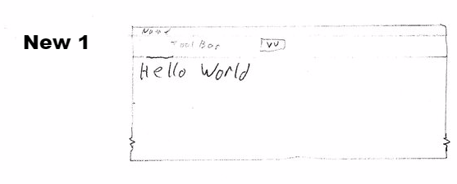

After hitting return, and expecting more than just a line printed, as a new user, he hits the “▼▼” curious as to what it does. He sees it lists his writing history.

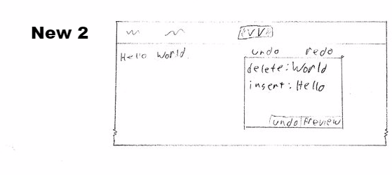

He selects the ‘World’ entry, then clicks undo:

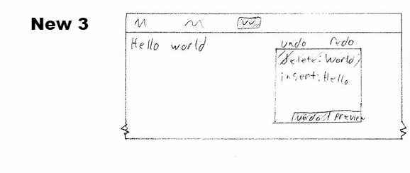

That action removes the ‘World’, then he renters it written with a lower case ‘w’.

While confused why nothing is happening in regards to the Hello World program he wishes to create, Billy is content with how Extreme Editor Plus™ functions as a text editor.

**Advanced**

Samantha is an experienced Extreme Editor Plus™ programmer, and is aware of the shortcuts and features a new user may not be aware of. She is going to edit a small program she coded earlier.

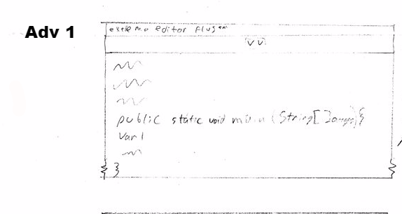

She enters a line ‘var 1’ consisting of something she wants to remove. She accidently removes both it, and the line above. Thus, she opens the undo/redo history, showing her previous actions:

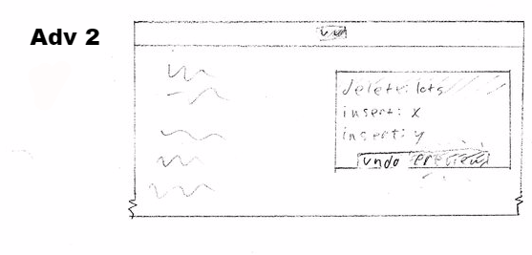

The ‘delete’ action being the most recent would contain her mistake. Just to be certain, she selects it and presses the Preview button, not wanting any uncertainty when editing this program.

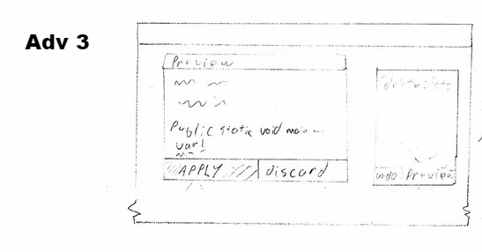

This opens the Preview pane, which appears over the normal work area, but a separate entity that can be moved or resized. As this replaces the line she mistakenly removes, she pressed the ‘Apply’ button, confirming the undo-delete action, resulting in:

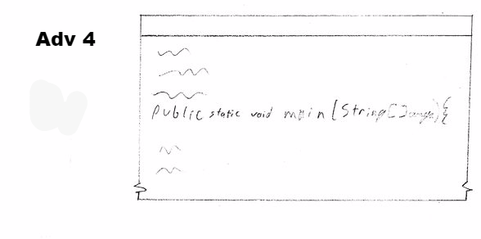

The line is replaced and Samantha removes ‘var 1’ more carefully.

This demonstrates the level of control and certainty Extreme Editor Plus™ can have, as Samantha doesn’t want to mistakenly change something risky with CRTL+Z, not seeing where the change takes place. She wanted more control.

**UI Design Thoughts**

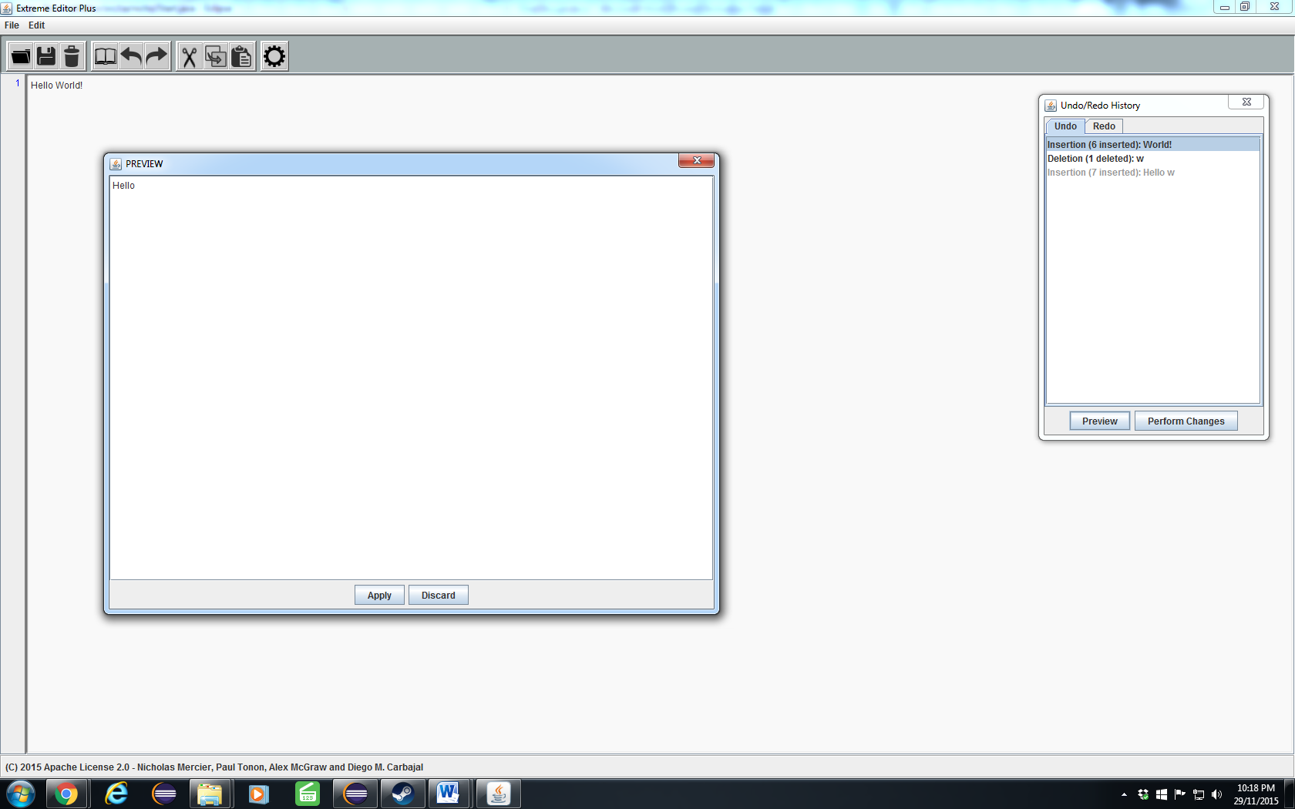

The UI was designed with visibility in mind, making the buttons visibly react when pressed. This involves the button having a red outline when hovered over, which turns green upon a mouse click. Clearly showing which button is used, and a distinct red or green upon the state.

This indicates to the user which action they are choosing without any doubt.

